Huawei Server Ansible roles
1.0
 | User Guide
 | Issue | 02
 | Date | 2018-11-02


Contents
1 About This Document 1
2 Overview 3
3 Installing and Uninstalling the Ansible roles 4
3.1 Installing the Ansible roles 4
3.2 Uninstalling the Ansible roles 5
4 Configuring the Ansible roles 6
5 Adding Managed Servers 7
6 Using the Ansible roles 9
6.1 Querying Driver and Firmware Versions 9
6.2 Upgrading Drivers and In-Band Firmware 11
6.3 Upgrading the BMC 13
6.4 Upgrading the BIOS 14
6.5 Automatic Upgrade 15
6.6 Restarting the OS 16
6.7 Uninstalling the HSU 17

About This Document
Purpose
This document describes how to install and uninstall the Huawei Server Ansible roles, how to query and upgrade Huawei server drivers and firmware, how to upgrade the BMC and BIOS, and how to perform an automatic upgrade.
Intended Audience
This document is intended for:
- Technical support engineers
- Maintenance engineers
Symbol Conventions
The symbols that may be found in this document are defined as follows.
Symbol | Description
 | Indicates an imminently hazardous situation which, if not avoided, will result in death or serious injury.
 | Indicates a potentially hazardous situation which, if not avoided, could result in death or serious injury
 | Indicates a potentially hazardous situation which, if not avoided, may result in minor or moderate injury.
 | Indicates a potentially hazardous situation which, if not avoided, could result in equipment damage, data loss, performance deterioration, or unanticipated results.  NOTICE is used to address practices not related to personal injury.
Calls attention to important information, best practices, and tips.
NOTE is used to address information not related to personal injury, equipment damage, and environment deterioration.

Change History
Issue | Release Date | Description
02 | 2018-11-02 | Modified 5 Adding Managed Servers.
01 | 2018-09-29 | This issue is the first official release.

Overview
The Ansible roles is a module running on the Ansible software.
You can implement the following functions by using this module:
- Querying driver and firmware versions
- Manual and automatic upgrade of drivers and in-band firmware
- Manual and automatic upgrade of the BMC and BIOS
- OS restart
The Ansible roles supports the following OSs on managed servers: Red Hat Enterprise Linux (RHEL) 6.9, 7.3, and 7.4.
The Ansible roles supports the following managed servers: 1288H V5, 2288H V5, 2288 V5, and 2488H V5.

Installing and Uninstalling the Ansible roles
3.1 Installing the Ansible roles
3.2 Uninstalling the Ansible roles

Installing the Ansible roles
Prerequisites
- Ansible 2.0.0 or later has been installed. For details, see the official Ansible website.
- You have obtained the Huawei Server Update Tool (HSU) software package.
Procedure
- Method 1:
            - Log in to the Ansible server as an administrator from an SSH tool, such as PuTTY.
            - Run the following command to install the Ansible roles:
# ansible-galaxy install Huawei.server-upgrade
[root@vps roles]# ansible-galaxy install Huawei.server-upgrade
- downloading role 'server-upgrade', owned by Huawei
- downloading role from https://github.com/Huawei/server-upgrade/archive/master.tar.gz
- extracting Huawei.server-upgrade to /root/.ansible/roles/Huawei.server-upgrade
- Huawei.server-upgrade(master) was installed successfully
Check the command output for the installation directory of the Ansible roles, which varies with the OS.
            - Upload the HSU software package to the /etc/ansible/roles/Huawei.server-upgrade/files directory on the Ansible server.
----End
- Method 2:
            - Download the Ansible roles package Huawei.server-upgrade vX.X.tar from the GitHub website.
            - Upload the package obtained in Step 1 to the roles directory in the Ansible installation directory and run the following command to decompress the package:
# tar -xvf Huawei.server-upgrade vX.X.tar
            - Upload the HSU software package to the /etc/ansible/roles/Huawei.server-upgrade/files directory on the Ansible server.
----End

Uninstalling the Ansible roles
            - Log in to the Ansible server as an administrator from an SSH tool, such as PuTTY.
            - Run the following command to go to the roles directory in the Ansible installation directory. The following uses the default installation path of Ansible as an example.
# cd /etc/ansible/roles
            - Run the following commands to delete the Huawei.server-upgrade folder:
# rm -rf Huawei.server-upgrade
----End

Configuring the Ansible roles
Configure the OS download source.
            - Log in to the Ansible server from an SSH tool, such as PuTTY.
            - Run the following command to go to the defaults directory:
# cd /etc/ansible/roles/Huawei.server-upgrade/defaults
            - Run the following command to open the main.yml file, and change the values of baseurl of CentOS, RHEL, and firmware to the correct URLs:
# vi main.yml
              - Changing baseurl
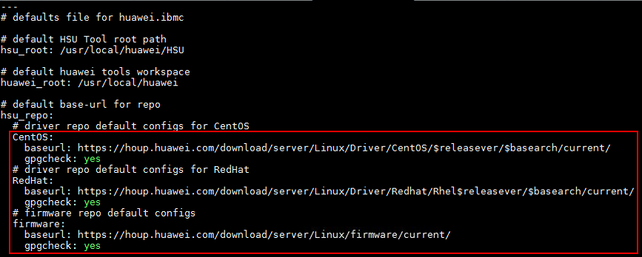

- By default, the value of baseurl is a URL on the Huawei Online Upgrade Platform. If you cannot connect to the Internet, you can create a local image source and change baseurl to the path of the local image source.
- The values of gpgcheck are as follows:
- yes (default): Verification is performed on the downloaded RPM package.
- no: Verification is not performed on the downloaded RPM package.
----End

Adding Managed Servers
            - Run the following command to go to the examples directory:
# cd /etc/ansible/roles/Huawei.server-upgrade/examples
            - Run the following command to add IP addresses of the managed servers (enter one IP address in each row): For example, to add the IP addresses 10.71.10.218 and 10.71.10.223, run the following command:
# vim inventory
[servers]
10.71.10.218
10.71.10.223
            - Run the following command to generate an SSH key for the managed server:
# ssh-keygen
[root@localhost ~]# ssh-keygen
Generating public/private rsa key pair.
Enter file in which to save the key (/root/.ssh/id_rsa):
Enter the directory where the key file is to be stored.
Enter file in which to save the key (/root/.ssh/id_rsa): /root/.ssh/id_rsa
Created directory '/root/.ssh'.
Enter a password and confirm it. If you do not enter a password, no password is not set.
Enter passphrase (empty for no passphrase):
Enter same passphrase again:
Your identification has been saved in /root/.ssh/id_rsa.
Your public key has been saved in /root/.ssh/id_rsa.pub.
The key fingerprint is:
SHA256:quMm3xdLH0XQ9k1Jq7dSS/Xjiq6R1QASGKfL4i++Uwg root@localhost.localdomain
The key's randomart image is:
+---[RSA 2048]----+
| .o+...o ...|
| .o . . + .o|
| . + . +.|
| E . . + o +|
| ...o S o o =.|
| .... .o + = +|
| .. .. * . . + |
| .o+o o o . o |
| .BBo.. .oo . |
+----[SHA256]-----+
            - Run the following command to authenticate the managed server:
# ssh-copy-id user@host
In this command, user indicates the user name for logging in to the managed server, and host indicates the IP address of the managed server. The following uses the server whose IP address is 10.71.10.218 as an example:
[root@ansible examples]# ssh-copy-id root@10.71.10.218
/usr/bin/ssh-copy-id: INFO: Source of key(s) to be installed: "/root/.ssh/id_rsa.pub"
The authenticity of host '10.71.10.218 (10.71.10.218)' can't be established.
ECDSA key fingerprint is SHA256:fJT1L/6HQZcDGmjsoiyF6U54kqS/3jnJnka658HqQpg.
ECDSA key fingerprint is MD5:b1:d0:35:a7:8e:f6:2f:0f:5d:dc:d1:1d:ec:c0:d5:76.
Are you sure you want to continue connecting (yes/no)?
Enter yes.
/usr/bin/ssh-copy-id: INFO: attempting to log in with the new key(s), to filter out any that are already installed
/usr/bin/ssh-copy-id: INFO: 1 key(s) remain to be installed -- if you are prompted now it is to install the new keys
root@10.71.10.218's password:
Enter the user name and password.
Number of key(s) added: 1
Now try logging into the machine, with: "ssh 'root@10.71.10.218'"
and check to make sure that only the key(s) you wanted were added.
            - Import the public key to the managed server.
- Download the public key (for example, GPG_KEY-Huawei-Server) from the Huawei Online Upgrade Platform and save it to any directory on the OS of the managed server.
- Run the following command in the directory where the public key is saved:
# rpm --import GPG_KEY-Huawei-Server
----End

Using the Ansible roles
If multiple servers are added and authenticated in 5 Adding Managed Servers, the following operations are performed on all these servers.
6.1 Querying Driver and Firmware Versions
6.2 Upgrading Drivers and In-Band Firmware
6.3 Upgrading the BMC
6.4 Upgrading the BIOS
6.5 Automatic Upgrade
6.6 Restarting the OS
6.7 Uninstalling the HSU

Querying Driver and Firmware Versions
            - Run the following command to go to the examples directory:
# cd /etc/ansible/roles/Huawei.server-upgrade/examples
            - Run the following command to query driver and firmware versions:
# ansible-playbook -i inventory upgrade-list.yml
PLAY [servers]*******************************************************************************************************************
TASK [Gathering Facts] **********************************************************************************************************
ok: [10.71.10.218]
TASK [Huawei.server-upgrade : Ensure HSU directory exists] *********************************************************************
ok: [10.71.10.218]
TASK [Huawei.server-upgrade : Ensure tar tool installed] ***********************************************************************
ok: [10.71.10.218]
TASK [Huawei.server-upgrade : Deploy Huawei Server Upgrade Tool] ***************************************************************
changed: [10.71.10.218]
TASK [Huawei.server-upgrade : include_tasks] ***********************************************************************************
included: /etc/ansible/roles/Huawei.server-upgrade/tasks/upgrade-list.yml for 10.71.10.218
TASK [Huawei.server-upgrade : Add Huawei Houp driver repo] *********************************************************************
changed: [10.71.10.218]
TASK [Huawei.server-upgrade : Add Huawei Houp firmware repo] *******************************************************************
changed: [10.71.10.218]
TASK [Huawei.server-upgrade : Gather Huawei Server upgrade list] ***************************************************************
ok: [10.71.10.218]
TASK [Huawei.server-upgrade : Display Huawei Server upgrade list] **************************************************************
ok: [10.71.10.218] => {
"failed_when_result": false,
"msg": {
"Drv-i40e": {
"type": "net",
"v-max": "2.4.6",
"v-use": "2.4.6",
"vlist": [
"2.4.6"
]
},
"Drv-megaraid_sas@0000:1c:00.0": {
"type": "raid",
"v-max": "07.703.09.00",
"v-use": "06.811.02.00-rh1",
"vlist": [
"07.703.09.00"
]
},
"FW-AL14SEB030N@68R0A15LF4VD": {
"type": "disk",
"v-max": "0805",
"v-use": "0805",
"vlist": [
"0805"
]
},
"FW-Bios": {
"type": "bios",
"v-max": "8.82",
"v-use": "8.82",
"vlist": [
"8.82"
]
},
"FW-iBMC": {
"type": "ibmc",
"v-max": "3.11",
"v-use": "3.11",
"vlist": [
"3.11"
]
}
}
}
PLAY RECAP **********************************************************************************************************************
10.71.10.218 : ok=9 changed=1 unreachable=0 failed=0
Table 1-1 describes the parameters.
                - Parameter description
Parameter | Description
Drv-xxx | Driver name
@0000:1c:00.0 | Bus number:Device number:Function number
FW-xxx | Firmware name
type | Firmware type
v-max | Latest version in the upgrade list
v-use | Current version
v-list | Upgrade list

----End

Upgrading Drivers and In-Band Firmware
Preparations
Before the upgrade, check the compatibility of the drivers and firmware of the target versions to prevent incompatibility issues. For details, see FusionServer iDriver V100R001C00 Driver Version Mapping Vxxx on Support > Product Support > Carrier IT > Server > FusionServer > Rack Server > FusionServer iDriver.
Procedure
            - Run the following command to go to the examples directory:
# cd /etc/ansible/roles/Huawei.server-upgrade/examples
            - Run the following command and enter the names and target versions of the drivers and in-band firmware in the inband-upgrade.yml file based on the query result in 6.1 Querying Driver and Firmware Versions:
# vim inband-upgrade.yml
              - Specifying the names and target versions of the drivers and in-band firmware to be upgraded
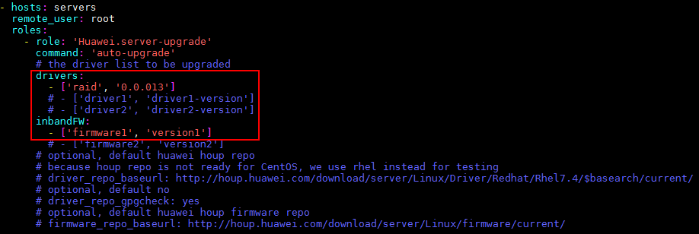

            - Run the following command to upgrade the drivers and in-band firmware:
# ansible-playbook -i inventory inband-upgrade.yml
              - Upgrading drivers and in-band firmware
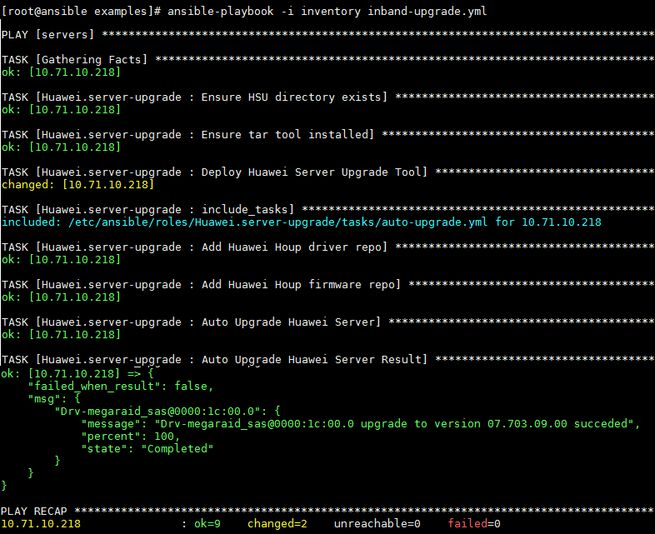

Check the Auto upgrade Huawei Server Result. If the result is "ok", the upgrade is successful. If the result is "failed", the upgrade fails. You can check the message row for failure causes.
----End

Upgrading the BMC
            - Run the following command to go to the examples directory:
# cd /etc/ansible/roles/Huawei.server-upgrade/examples
            - Run the following command and enter BMC upgrade information in the bmc-upgrade.yml file based on the query result in 6.1 Querying Driver and Firmware Versions. Then save the settings and exit.
# vim bmc-upgrade.yml
              - Modifying BMC information


            - Run the following command in examples directory to upgrade the BMC:
# ansible-playbook -i inventory bmc-upgrade.yml
              - Upgrading the BMC
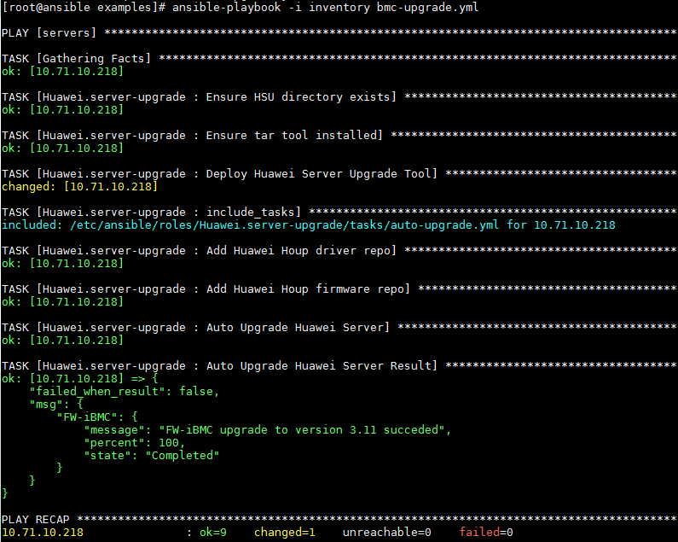

----End

Upgrading the BIOS
            - Run the following command to go to the examples directory:
# cd /etc/ansible/roles/Huawei.server-upgrade/examples
            - Run the following command and enter BIOS upgrade information in the bios-upgrade.yml file based on the query result in 6.1 Querying Driver and Firmware Versions. Then save the settings and exit.
# vim bios-upgrade.yml
              - Modifying BIOS information
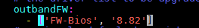

            - Run the following command in examples directory to upgrade the BIOS:
# ansible-playbook -i inventory bios-upgrade.yml
              - Upgrading the BIOS
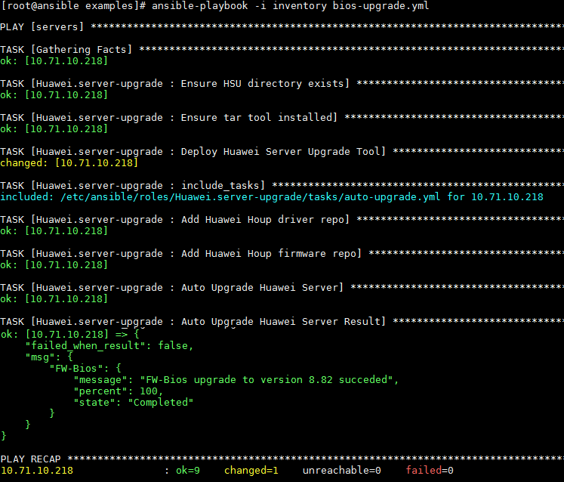

----End

Automatic Upgrade
In automatic upgrade, a driver is automatically upgraded when the latest version in the upgrade package library is later than the current version, and the in-band firmware is automatically upgraded when the version in the library is inconsistent with the current version.
            - Run the following command to go to the examples directory:
# cd /etc/ansible/roles/Huawei.server-upgrade/examples
            - Run the following command in the examples directory:
# ansible-playbook -i inventory auto-upgrade.yml
              - Automatic upgrade
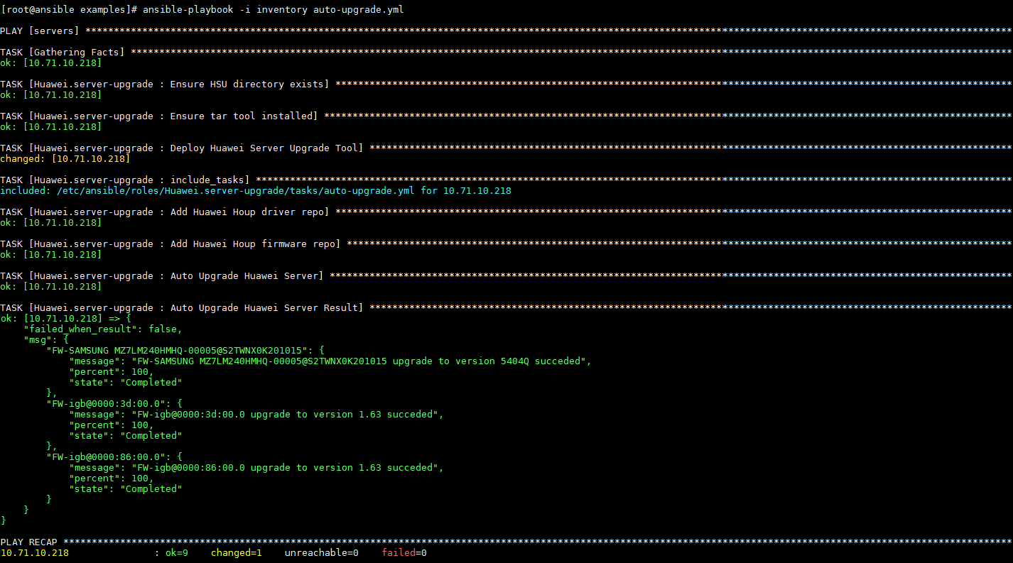

----End

Restarting the OS
            - Run the following command to go to the examples directory:
# cd /etc/ansible/roles/Huawei.server-upgrade/examples
            - Run the following command in the examples directory to restart the OS:
# ansible-playbook -i inventory restart.yml
              - Restarting the OS
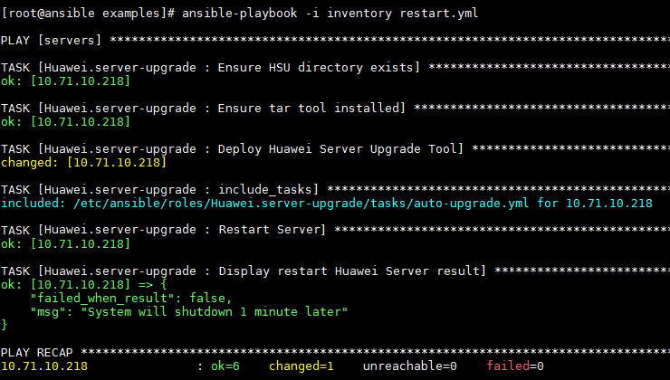

----End

Uninstalling the HSU
            - Run the following command to go to the examples directory:
# cd /etc/ansible/roles/Huawei.server-upgrade/examples
            - Run the following command in the examples directory to uninstall the HSU:
# ansible-playbook -i inventory remove-hsu.yml
              - Uninstalling the HSU
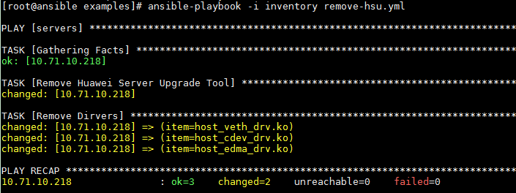

----End

